What issue for would like to work on today? Possibilities include :-
- Anger & Irritation
- Managing Stress better
- Improving Relationships
- Reducing Procrastination
- Finding satisfying work
- Managing worry and anxiety better
- A decision you need to make
- Managing low mood & feeling demotivated
- Career performance
- Become happier and more fulfilled
- Achieve your Goals (e.g. for the next year)

I would like to work on

Stoicism Made Simple in 4 Sentences

Rational judgement, now, at this very moment.
“Virtuous action, now, at this very moment. (Wisdom, Courage, Self-control, Justice)
Willing acceptance - now, at this very moment - of what you can’t change
That's all you need.” Adapted from Marcus Aurelius, Meditations, 9.6

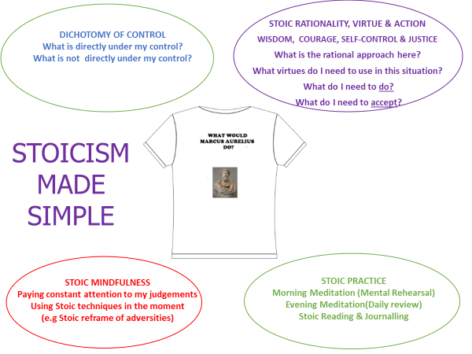
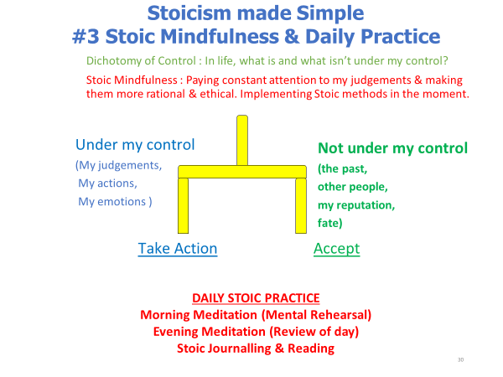

My issue:

What I cannot control | What I can control

Use of virtues (and how)

Virtue | How to use
Wisdom | Focus on what I can control. Remember doing my best (virtues) matters most.
Courage

Self-Control

Justice

Action Plan (Practical Wisdom)

On a scale of 0-10, how useful does this model seem?

